RAFFLE
Autographed Jersey by T.J. OSHIE
Autographed Hockey Stick by NIC DOWD
Autographed Hockey Puck by TOM WILSON

Raffle Tickets are
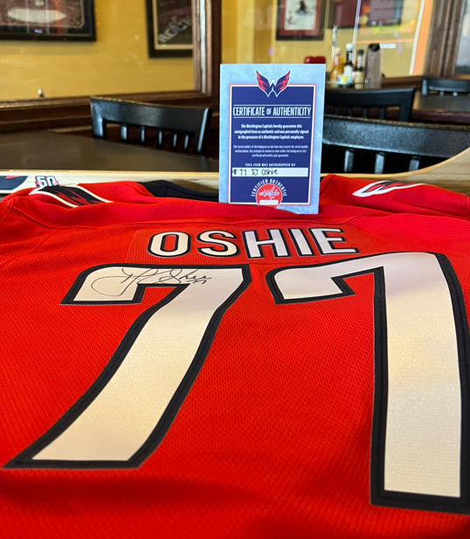
$20 each

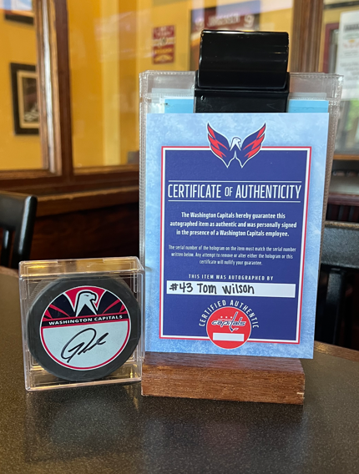

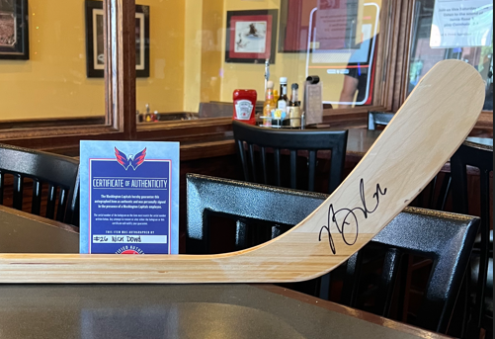

Drawing will be held on September 21st
@ South Riding Inn

Tickets can be purchase at

https://www.mywshsalumni.com/

